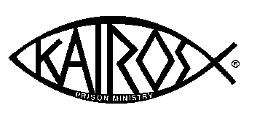
Coffield Kairos Cookies

Homemade cookies are a tangible expression of Christian love, and they are used as a symbol of God's agape love on a Kairos weekend. Because the cookies are going into a prison, we must follow prison guidelines for what can – and cannot - go into the unit. We know that each person who bakes cookies does so with the best intentions, so we offer the following suggestions to help ensure that all cookies arrive in excellent condition, ready for distribution in the unit.

Please follow these directions. Call your contact for any clarification.

- Pray over the cookies while baking.

- Cookie ingredients: No nuts or icing please.

- No brownies or bar cookies.

Approximate 3 inches

- Using a cookie scoop when making cookies makes them similar size. They pack easier when placing in the box.

- Prefer no extra-large cookies. They break when transported.

- Do not over-bake and cool well before stacking. (this prevents crumbling).

- Place in 1gallon Ziplock bag or cardboard box separated by “wax paper”. Please, no foil or Suran wrap.

- Label bag/box with the type of cookies and how many dozen.

- Cookies can be frozen if made in advance. If you have no freezer space we can help.

Contact: ______________
Phone: _____________

To be delivered or picked up by: _____________

